**DHT11 Humdity & Temperature Sensor**

### **Introduction**

In this project we will be Interfacing DHT11 Humidity & Temperature Sensor with Arduino & LCD. We will design a device that will be capable of measuring room temperature and environmental humidity. Simply we will design a digital humidity and temperature meter using Arduino and DHT11 sensor with the value displayed on LCD.

This DHT11 Temperature and Humidity Sensor features a calibrated digital signal output with the temperature and humidity sensor complex. Its technology ensures the high reliability and excellent long-term stability. A high-performance 8-bit microcontroller is connected. This sensor includes a resistive element and a sense of wet NTC temperature measuring devices. It has excellent quality, fast response, anti-interference ability and high cost performance advantages.

### **DHT11 Humidity & Temperature Sensor**

#### **Introduction:**

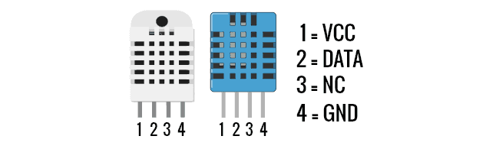

This DHT11 Temperature and Humidity Sensor features a calibrated digital signal output with the temperature and humidity sensor complex. Its technology ensures high reliability and excellent long-term stability. A high-performance 8-bit microcontroller is connected. This sensor includes a resistive element and a sense of wet NTC temperature measuring devices. It has the excellent quality, fast response, anti-interference ability, and high-cost performance advantages.

Each DHT11 sensor features an extremely accurate calibration of the humidity calibration chamber. The calibration coefficients stored in the OTP program memory, internal sensors detect signals in the process, we should call these calibration coefficients. The single-wire serial interface system is integrated to become quick and easy. Small size, low power, signal transmission distance up to 20 meters, making it a variety of applications and even the most demanding applications. The product is 4-pin single row pin package. Convenient connection, special packages can be provided according to users’ needs.

#### **Features:**

1. Low cost  
2. 3 to 5V power and I/O  
3. 2.5mA max current use during conversion (while requesting data)  
4. Good for 20-80% humidity readings with 5% accuracy  
5. Good for 0-50°C temperature readings ±2°C accuracy  
6. No more than 1 Hz sampling rate (once every second)  
7. Body size 15.5mm x 12mm x 5.5mm  
8. 4 pins with 0.1″ spacing

#### **Working**

The sensor consists of a humidity sensing component, a NTC temperature sensor (or thermistor) and an IC on the backside of the sensor.

[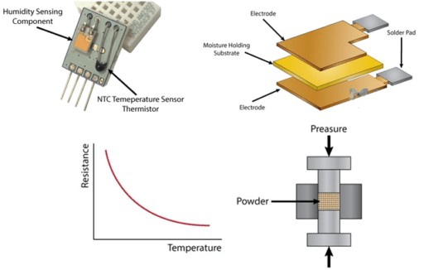](https://how2electronics.com/wp-content/uploads/2018/06/Untitled-1-512x326.jpg)

On the other hand, for measuring temperature these sensors use an NTC temperature sensor or a thermistor. A thermistor is actually a variable resistor that changes its resistance with a change in temperature. These sensors are made by sintering semiconductive materials such as ceramics or polymers in order to provide larger changes in the resistance with just small changes in temperature. The term “NTC” means “Negative Temperature Coefficient”, which means that the resistance decreases with the increase in the temperature.

## DHT11 Communication Protocol

* DHT11 sensor uses a **single-wire, two-way Serial Protocol** for communicating with third-party peripherals normally microcontrollers.
* We call it **single-wire** because the communication is performed through a single pin.
* It’s **two-way** because DHT11 receives commands from the microcontroller and then responses back required data.
* Data sent by the DHT11 sensor is **40bits** and it sends **Higher Data Bits** first.
* Data contains both **Integral and decimal values** of temperature and relative humidity along with a checksum value.

## DHT11 Communication with Microcontroller

* The **circuit diagram** to interface **DHT11 with microcontroller** is shown in the below figure:

[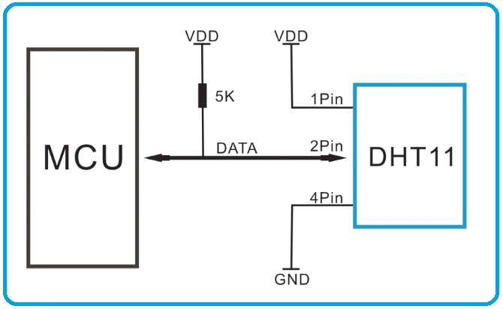](https://www.theengineeringprojects.com/wp-content/uploads/2019/03/DHT11-Communication-with-Microcontroller.png)

* **Pull-up resistance of 5k ohm** is recommended to place at the Data Pin of DHT11 sensor.
* At normal conditions, the data pin of DHT11 remains at the **HIGH voltage level** and the sensor remains in **low power consumption mode**.
* In order to receive data from the DHT11 sensor, the microcontroller should make the **Data Pin low for at least 18us**, so that the sensor could sense it.
* Once the DHT11 sensor senses the low signal at the Data Pin, it changes its state from **low power consumption mode to running mode** and waits for the Data Pin to get HIGH.
* As the **Data Pin gets HIGH** again by the microcontroller, DHT11 sends out the **40-Bit calibrated output value serially**.
* After sending the data, DHT11 goes back to low power consumption mode and **waits for the next command** from the microcontroller.
* The microcontroller has to **wait for 20-40us** for getting a response from the DHT11 sensor.